**MINOR PROJECT REPORT**

Design and Fabrication of Roaster Arrangement for food items



**Group 12: Mentor:**

Gursharan Kaur- 20107015

Priyanshu- 20107017

Aditya Singh- 20107031 Dr. Gurjeet Singh

Vanshika- 20107044 (Mechanical Engineering

Department)

**TABLE OF CONTENTS**

| **Sr. No.** | **Heading** | **Page No.** |
| --- | --- | --- |
| **1** | **Title & Cover Page** | **1** |
| **2** | **Table of contents** | **2** |
| **3** | **Declaration** | **3** |
| **4** | **Acknowledgments** | **4** |
| **5** | **Introduction** | **5** |
| **6** | **Motivation** | **6** |
| **7** | **Objectives** | **7** |
| **8** | **Project Details**  *8.1 Components*  *8.2 Design*  *8.3 Fabrication*  *8.4 Working*  *8.5 Challenges faced* | **8-10**  **11**  **12-13**  **14**  **15** |
| **9** | **Bill of material** | **16** |
| **10** | **Timeline** | **17** |
| **11** | **Conclusion** | **18** |
| **12** | **Future Scope** | **19** |
| **13** | **References** | **20** |

**DECLARATION**

We, the students of Group-12, hereby declare that this project report is the record of authentic work carried out by us under the guidance of Dr. Gurjeet Singh, Professor from Mechanical Engineering Department, PEC Chandigarh, for the Academic Session - 22231 and has been submitted as a part of our mid-term evaluation of the minor project.

**Date:**

19/12/2022

**Day:**

Monday

**Group-12 Members:**

Gursharan Kaur (20107015)

Priyanshu (20107017)

Aditya Singh (20107031)

Vanshika Garg (20107044)

**ACKNOWLEDGMENTS**

We are extremely grateful to our mentor, Dr. Gurjeet Singh from Mechanical Engineering Department for his wholehearted support, suggestions and valuable advice throughout the mechanics of the project work and in the preparation of this report.

We also express our gratitude to the evaluation committee:

Dr. D R Prajapati (Chairman),

Prof. A N Dubey (Coordinator cum Instructor),

Dr. C K Shusheel, Dr. Niharika Gupta, Dr. Debasish Das and Dr. Homender Kumar (members) and,

all the mechanical faculty supervisors for their valuable comments and suggestions.

We express sincere gratitude to our esteemed Director Dr. Baldev Setia for fostering an atmosphere of holistic education which helped in the completion of this project work.

Last but not the least, we take this opportunity to thank our family members and friends who provided all the backup support throughout the project work.

**INTRODUCTION**

Most of the delicious food items like roasted corn, soya chaap, and paneer tikka are cooked either by subjecting them to dry heat or over a fire as in the case of roasting. Roasting is an important method of processing since it is typically thought to be more pleasant and has rich flavors and tastes than unroasted maize. Both young and old around the world like eating maize in its preferred form, which is roasted. The economic situation in most developing countries has left small-scale sellers in an unhygienic environment. The productivity is often too low to justify labor and time investment. This method also removes moisture from the items. As a result, the success of the roasting process determines the quality of the roasted product.

Therefore, our goal is to take advantage of this stable market by developing a machine that is low-cost, clean, hygienic, partially sustainable, and highly efficient in utilizing heat for local vendors.

Concerning these challenges particularly associated with the roasting of corn, a roaster was designed and fabricated. The mechanized gas-fueled corn roaster consists of a frame, roasting unit, food tray, air-blowing unit, and a power transmission system. The developed roaster can effectively address the need of rural dwellers as well as small and medium-scale processors, which would subsequently contribute to economic empowerment and alleviation of food insecurity in areas where this food product has a large market.

**MOTIVATION**

In India, roasted corn is a popular snack that is sold on the roadsides by street vendors. Consequently, the vendors need exposure to better and more affordable technology for the same.

The conventional roasting method was integrated with a fan operated by hand to blow air onto the charcoal cinders and keep them red-hot. Over time, the roasting processes become so strenuous, that the operator tires out before the corn is completely roasted. Few corn cobs are thus roasted over long hours making consumers wait, while some eventually lose interest. The process is usually done by women and children, under uncomfortable conditions. This results in profuse sweating and relative discomfort due to contact and long-term exposure emanating from the burning charcoal. Also, consumers have become more health conscious and are slowly becoming aware of the ill effects caused to their health upon consuming roasted corn. This problem has arisen owing to the adherence of charcoal ash onto the corn as they are roasted directly on the charcoal cinders without any protective covering. It has damaging effects on the skin and organs and may lead to a person's low productivity.

To address these impending challenges, there is a need to come up with a solution that reduces human labor and ensures maximum roasting efficiency by designing and constructing a mechanized gas-fuelled corn roaster. Therefore, the constructed roaster is envisaged to deliver the desired and safe roasted corn for its intended consumers.

**OBJECTIVES**

In India, roasted food has a huge market because of which daily consumption of roasted food products is very high. The roasting of food through conventional methods leads to human fatigue, unhygienic food, adherence of ash onto corns, soya chaap, paneer roasting, etc. conventional method produces low thermal efficiency. Roaster arrangement of food items so as to increase the thermal efficiency, and produce hygienic food because here we have installed closed casing. Through this, users will only need to place and remove the food items inside the system. The user will not need to ignite the system for heating which will help reduce the burning hazard to the user. Energy wastage is reduced by this method.

So, in short the objective is to develop a system that:

* Ensures better roasting efficiency
* Reduces energy wastage
* Gives hygienic food product
* Is operated mechanically

**PROJECT DETAILS**

**Components :**

**1. Burner & Ignitor**

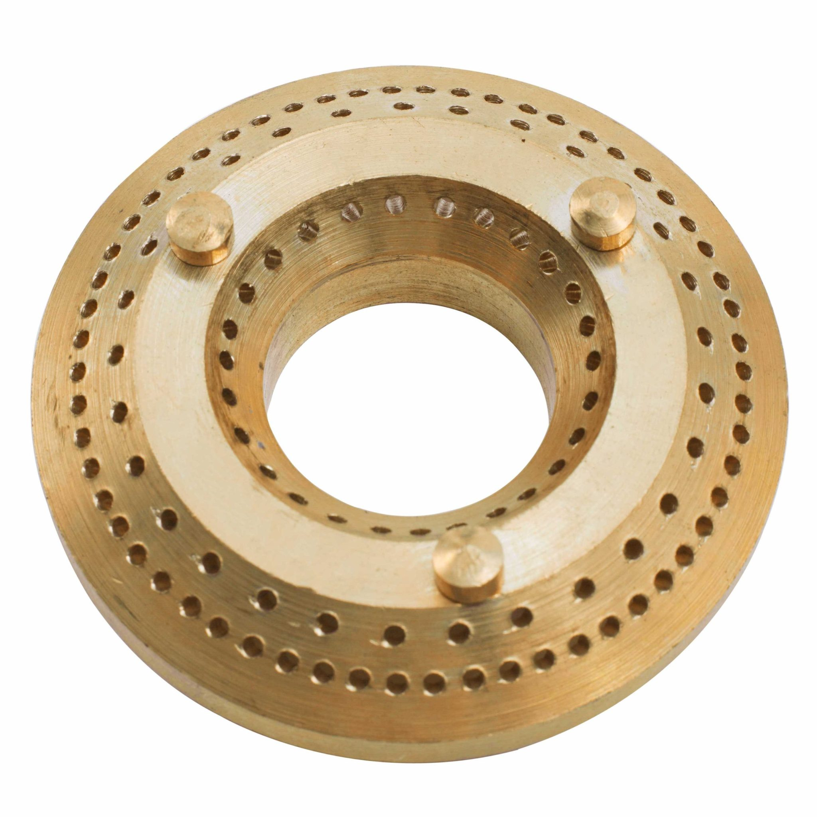 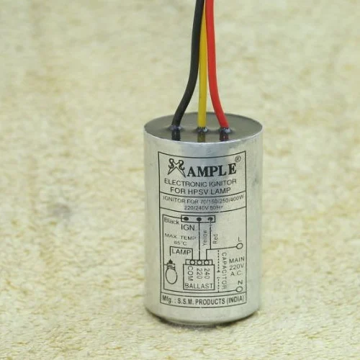

**2. Fan & its D.C. Motor**

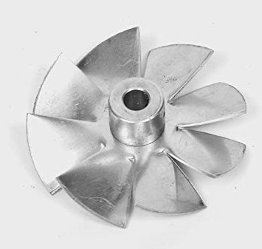 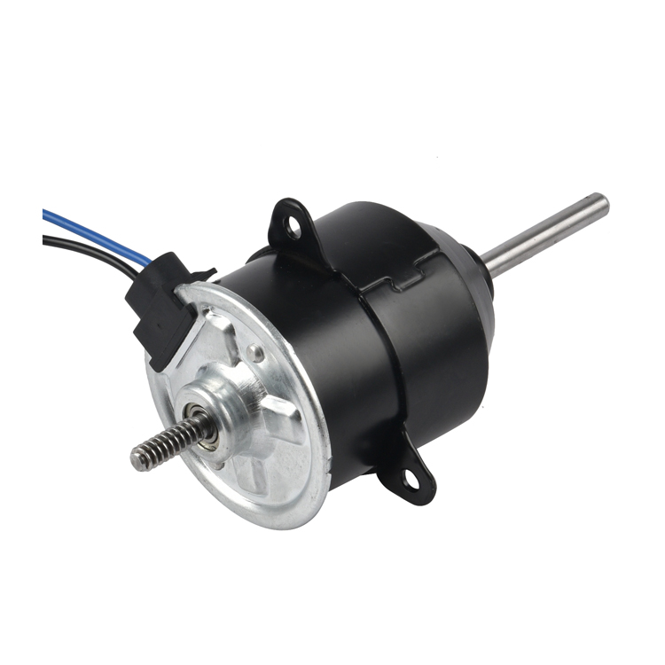

**3. Temperature Module**

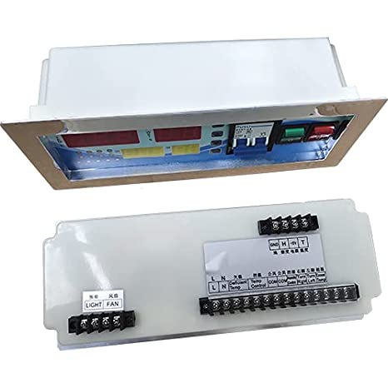

**4. Battery**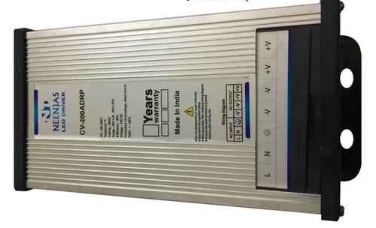

**5. Solenoid** 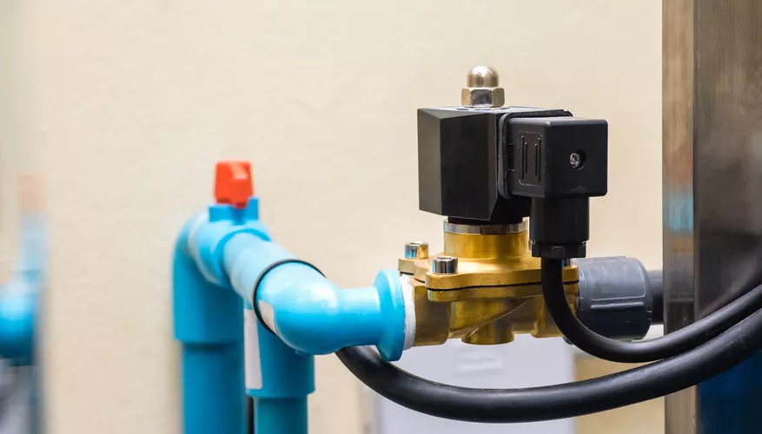

**6 .Gas valve**

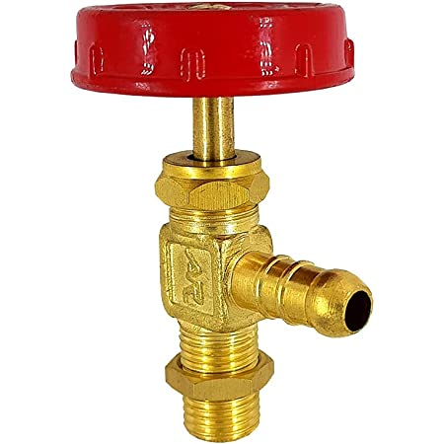

**7 . Frame (The main body)**

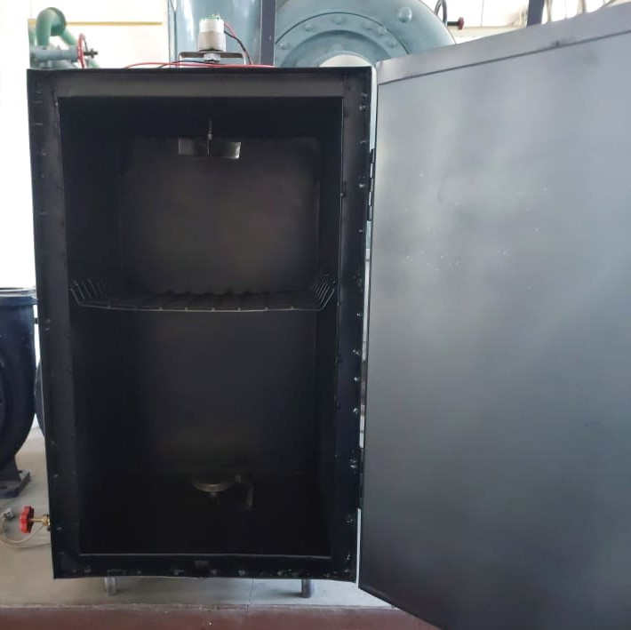

**DESIGN**

For the design of this system, we have used a burner which will be producing flame. We have inserted a nozzle through which LPG gas is supplied and it can control the supply of gas as per requirement. For initiating the flame, we have installed an ignitor which will produce a spark for 1 second. The whole system will be made insulated to avoid wastage of heat and to increase thermal efficiency. A fan blower is used to circulate the heat in the complete system so that uniform heating takes place in the system. Stacking can be done so as to get the maximum efficiency. We have used a temperature and time module to control the temperature inside the system. We can set maximum and minimum temperature inside the casing.

The design previously planned by us is shown in the figure given below.

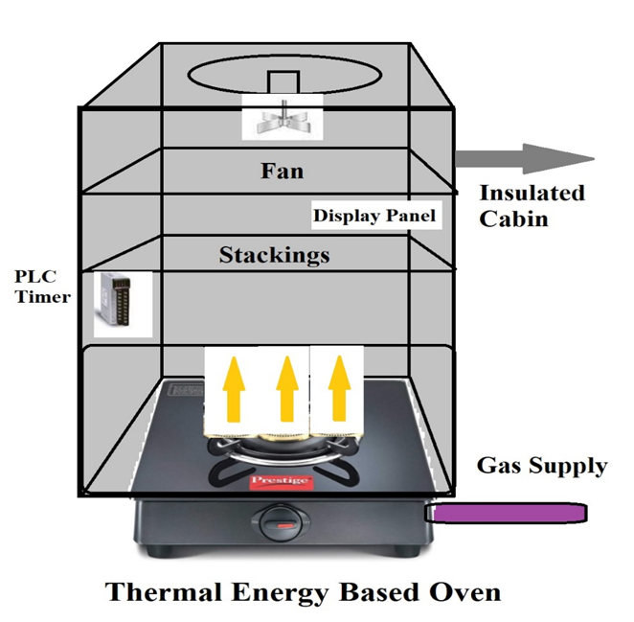

**FABRICATION**

In the casing, we have used glasswool material full sheet of 8*4 meter square for making the system insulated to avoid wastage of heat and to increase thermal efficiency. The fan blower is used to circulate the heat in the complete system so that uniform heating takes place in the system and is installed at the top of the system. It is run by a fan DC motor. The LPG gas supply is taken from commercially-available LPG cylinders. We have used a burner which will be producing flame. We have inserted a nozzle through which LPG gas is supplied and it can control the supply of gas as per requirement. For initiating the flame, we have installed an ignitor which will produce a spark for 1 second. The material of the ignitor is ceramic. It is connected with an induction coil using a tin-plated copper wire. A solenoid is installed to cut off the gas supply if the temperature reaches the maximum set by the user. A 12-V battery is used for the functioning of the electrical components: induction coil and solenoid. The induction coil works at 3.6 V so a step-down transformer is used to decrease the potential from 12V to 3.6V. The temperature and time controller module is used to set the range of temperature of the system and the time for the ignitor. Also, the temperature inside the system is displayed on this module.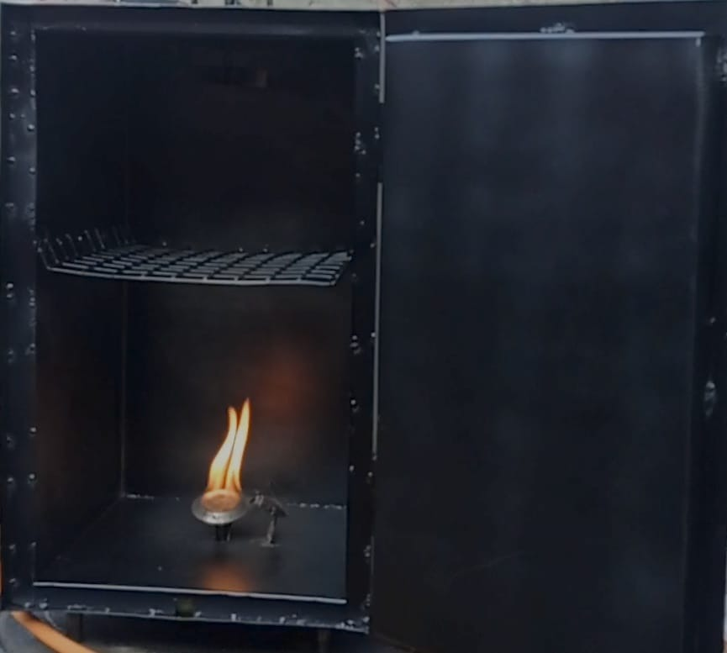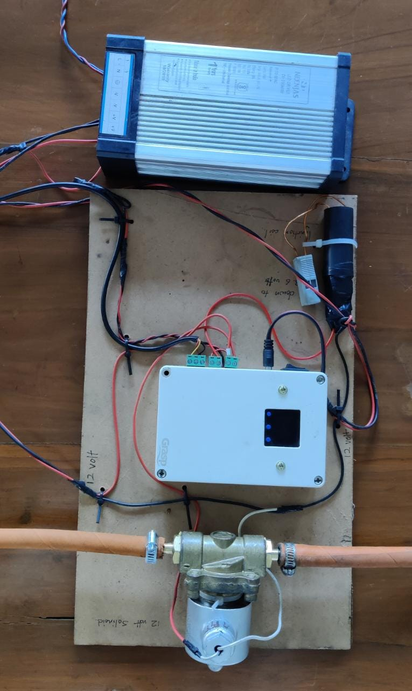

The two pictures below have been added from the ppt presented during the evaluation.

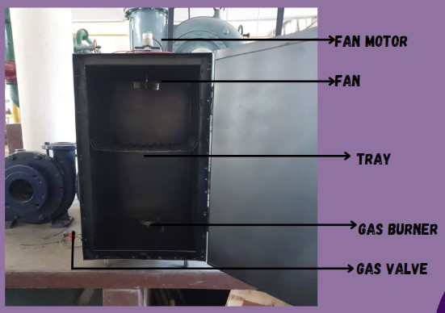

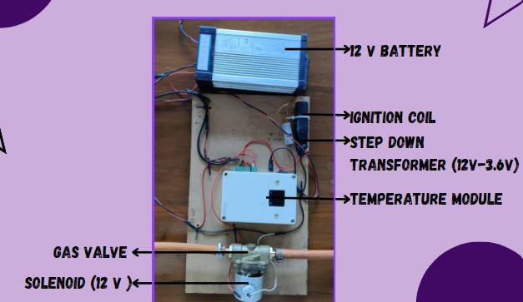

**WORKING**

As for the first step of the working system, we’ll plug the main electrical supply into the 220V standard voltage supply in India. We’ll switch on the temperature and time controller and set the range required in the system (typically, 25-30 degree Celsius). With the help of a 12V battery, we’ll supply electricity to the solenoid and induction coil. The induction coil produces a spark inside the casing for 1 second at regular intervals. It works at 3.6V so we have used a step-down transformer to decrease the voltage from 12V to 3.6V. The solenoid either starts or cuts off the gas supply depending upon the temperature inside the system making sure that the temperature inside the system remains in the range specified using the temperature module. The current from the induction coil is supplied to the ignitor which produces a spark for 1 second. When it comes in contact with an LPG gas supply, the ignition takes place. The blower operates with the help of a DC motor which runs on a separate battery. The LPG supply is provided from a commercial-LPG cylinder through a valve/nozzle attached to the casing. The nozzle controls the quantity of gas supply. Once the temperature becomes more than the maximum temperature specified, the induction coil cuts off the gas supply.



**CHALLENGES FACED**

While fabricating, we need to adjust the timings according to our college schedule and workshop timings under our expertise. We needed a higher voltage source for running the ignitor but that was consuming higher voltage because of this we are not able to run the fan at the spot. We were not able to perform any kind of energy analysis on food items. The voltage drop leads us to use an external motor for running the fan blower.

**BILL OF MATERIALS**

| Sr. No. | Items | Cost (In INR per unit) | Number of units used | COST (in INR) |
| --- | --- | --- | --- | --- |
| 1 | Temperature Module | 5000/- | 01 | 5000/- |
| 2 | Solenoid | 700/- | 01 | 700/- |
| 3 | Glass wool full sheet | 100/- per m^2 | 8*4 m^2 | 3200/- |
| 4 | Induction Coil | 900/- | 01 | 900/- |
| 5 | Step Down Transformer | 100/- | 01 | 100/- |
| 6 | Motor | 190/- | 01 | 190/- |
| 7 | Fan | 200/- | 01 | 200/- |
| 8 | Burner | 50/- | 01 | 50/- |
|  | Total Cost |  |  | 10,340/- |

**TIMELINE**

August 2022 December 2022



Synopsis Mid-Sem Fabrication ready &

Submission Evaluation End-Sem Evaluation

(13.09.2022) (18.10.2022) (19.12.2022)

**CONCLUSION**

The roasting food market is huge, especially in India but the conventional method used for roasting leads to enormous heat losses and has hazardous effects on the seller as well as the consumer when exposed to the coal. With this in mind, our primary objective was to design and fabricate a mechanized gas-fuelled roaster.

The roaster reduces heat wastage and improves the roasting efficiency without impacting the taste of the food item. As it is operated mechanically, the street vendor doesn’t face fatigue and doesn't get exposure to the coal. It also satisfies the needs of consumers as the food is hygienic and doesn’t have any ill effects on the body. The roaster can also be run on solar energy after some modifications and instead of an LPG gas supply, we can also use a CNG supply.

Therefore, this project has a wider perspective mainly focused on the efficient use of energy, and can be commercialized leading to better health and food security.

**FUTURE SCOPE**

We can do the energy analysis of various food items according to temperature differences in the system. We can measure the efficiency of our system and compare it with the conventional system. We can increase the stacking and cook, bake or roast various food items at the same time. Cost-cutting can be done by searching for alternative materials and components for the system. We can check if we can use some other fuel and check if we can get higher efficiency with lower cost as compared to the cost of LPG.

**REFERENCES**

· Abdulrahaman, A.A. and Kolawole, O.M. (2006). Traditional DESIGN & DEVELOPMENT OF GAS FUELLED CORN ROASTER 838-843 843 Hind Agricultural Research and Training Institute Agric.

· (TECHSEAR-3) 2017 : preparations and uses of maize in Nigeria. Ethno Botanical Leaflets

· Fellows, P.J. (2000). Food Processing Technology; Principles and Practice 2nd edition, Wood Head Publishing Company: Cambridge, UK

· Franca, A.S., Oliveira, L.S., Oliveira, R.C.S., Mancha Agresti, P.C. and Augusti, R. (2009). A preliminary evaluation of the effect of processing temperature on coffee roasting degree assessment. J. Food Engg.

· Mato, C.N. and Obembe, B.O. (2008). charcoal-roasted plantain and fish vendors in Port Harcourt: A potential anesthetic high risk group, Southern African J. Anaesthesia & Analgesia

· Shrivastava, Shikha, Sahu, Praveen, Singh, Akanchha and Shrivastava, Lekhika (2015). Fly ash disposal and diseases in nearby villages (A Survey), Internat. J. Curr. Microbiol. App. Sci.